
Project DS 3002 Data Mining
Surgical Data Analysis
Group Members:
Sohaib Ahmed (21L-5635)
Muhammad Hassan Khalid (21L-5692)
Muhammad Hamza (21L-5636)

Introduction:
The objective of this project is to develop predictive models for binary classification, specifically to predict the likelihood of surgical complications based on patient characteristics and surgical parameters. The dataset utilized for this analysis is sourced from Kaggle (https://www.kaggle.com/datasets/omnamahshivai/surgical-dataset-binaryclassification/data). It encompasses comprehensive information pertaining to surgical procedures and patient details, aiming to forecast surgical complications. The dataset comprises features including patient demographics, medical history, and surgical parameters. Our task involves constructing predictive models capable of accurately forecasting the likelihood of complications during surgical procedures based on these features.

Objective:
The main objective of the project is to identify factors influencing surgical complications and mortality rates. By analyzing these factors, healthcare providers can better understand the risks associated with surgeries and take necessary precautions to improve patient outcomes.

Dataset Overview:
The dataset encompasses features such as patient demographics, medical history, and surgical parameters. These features serve as predictors for surgical complications, which are represented as binary outcomes.

Library Utilization Overview:
A comprehensive set of libraries was employed for various stages of the project. Pandas and NumPy were utilized for data manipulation and preprocessing tasks, while Matplotlib and Seaborn facilitated data visualization, offering insights into the dataset's characteristics. Plotly was employed for interactive visualization, enhancing the presentation of results. Scikit-learn provided a wide range of tools for preprocessing, model building, and evaluation, including techniques for data splitting, feature scaling, and model selection. TensorFlow and Keras were leveraged for implementing neural network models, enabling sophisticated deep learning architectures. Overall, these libraries collectively supported the project in data handling, analysis, and modeling, contributing to its success in developing predictive models for surgical complications.

Exploratory Data Analysis (EDA):
we conducted an exploratory data analysis (EDA) to gain insights into the surgical dataset. Initially, we examined missing values within the dataset, identifying columns with missing data and their respective percentages. Subsequently, we assessed the class distribution to check for any class imbalances, which could influence model performance. Visualizing the class distribution through a count plot provided a clear understanding of the distribution of complications within the dataset. To ensure the robustness of our analysis, we performed outlier removal using the Interquartile Range (IQR) method and handled missing values by replacing them with the median of their respective columns. Additionally, we generated a correlation heatmap to observe the relationships between different features, which can inform feature selection and model building. Finally, we visualized the distribution of numerical features through histograms, offering insights into their distributions and potential transformations required for preprocessing.
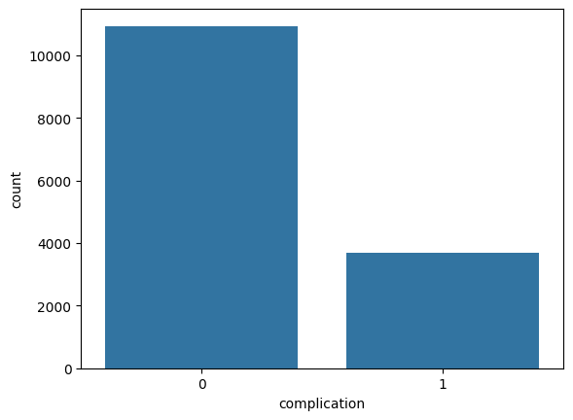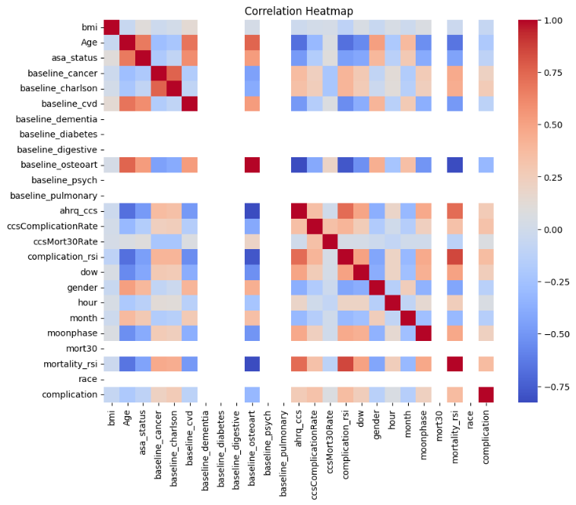
Model Training:
In the model training phase, we employed several classification algorithms to predict surgical complications based on patient characteristics and surgical parameters. The performance of each model was evaluated using metrics such as accuracy, precision, recall, F1 score, and area under the ROC curve (AUC). Among the models tested, Gradient Boosting exhibited the highest accuracy of 94.97%, with a notable precision of 93.62% and recall of 68.04%. Random Forest also demonstrated strong performance with an accuracy of 91.93%, while Decision Tree achieved an accuracy of 91.36%. Logistic Regression, although achieving a lower accuracy of 87.18%, provided valuable insights into the predictive power of linear models in this context. However, SVM and KNN showed relatively lower performance compared to other models, indicating their limitations in capturing the complexity of the dataset. Additionally, Naive Bayes exhibited a moderate performance with an accuracy of 65.72%. Visualizing the Receiver Operating Characteristic (ROC) curves further illustrated the trade-offs between true positive and false positive rates for each model, with Gradient Boosting showing the highest discriminatory power.

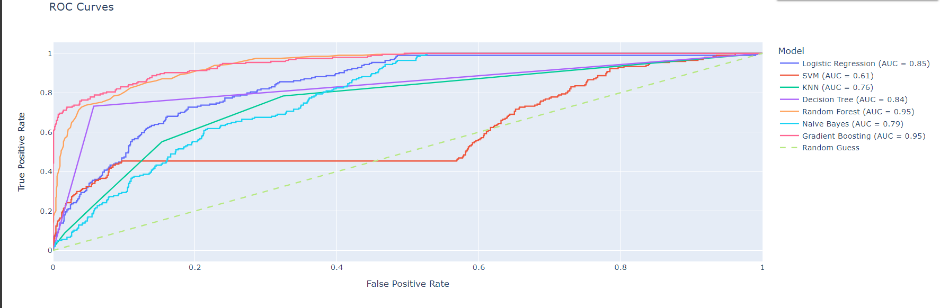
Neural Network For Classification:
A Neural Network model was trained to predict surgical complications based on the preprocessed dataset. The neural network architecture consisted of two hidden layers with 64 and 32 neurons, respectively, both activated by the Rectified Linear Unit (ReLU) function. The output layer utilized a sigmoid activation function to produce binary classification outputs. The model was compiled using the Adam optimizer and binary cross-entropy loss function, with accuracy as the evaluation metric.
Training the neural network involved 100 epochs with early stopping implemented to prevent overfitting, utilizing 20% of the training data for validation. After training, the model's performance was evaluated on the test set, achieving a test accuracy of 88%. The confusion matrix revealed 1184 true negatives, 34 false positives, 142 false negatives, and 52 true positives. Further analysis through the classification report indicated precision, recall, and F1-score values of 0.89, 0.97, and 0.93 for class 0 (no complication), and 0.60, 0.27, and 0.37 for class 1 (complication), respectively.
Moreover, the mean squared error (MSE) and root mean squared error (RMSE) for the neural network model were calculated as 0.1246 and 0.3531, respectively, highlighting the model's predictive accuracy. Visualizing the training and validation loss over epochs provided insights into the model's convergence and generalization performance. Overall, the neural network model demonstrated promising results in predicting surgical complications, contributing valuable insights for clinical decision-making and risk assessment.
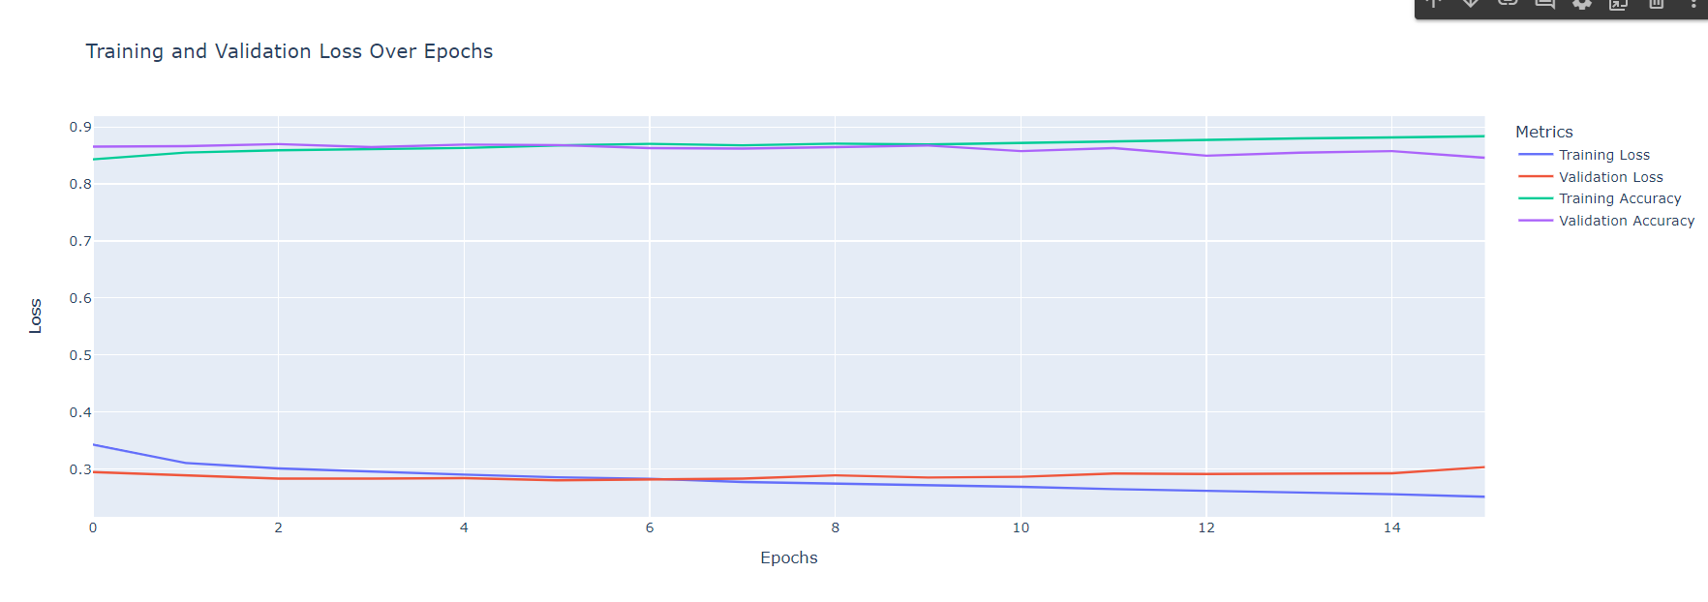

Feature Engineering:
Several feature selection techniques were applied to improve model performance and computational efficiency. First, the importance of features was evaluated using a Random Forest classifier, and the top k features were selected based on their importance scores. Subsequently, various machine learning models were trained using only the selected top features and evaluated for their performance metrics.
The results showed that Gradient Boosting achieved the highest accuracy of 94.69% when trained with the top features, followed closely by Random Forest with 93.84% accuracy. However, when comparing these results with the performance of models trained using all features, it was observed that the Gradient Boosting model achieved a slightly higher accuracy of 94.97% with all features, indicating that using all features might be beneficial in this case.
Additionally, the Recursive Feature Elimination with Cross-Validation (RFECV) technique was employed to automatically select the optimal number of features. The RFECV method identified four key features ('bmi', 'Age', 'complication_rsi', 'mortality_rsi') as the most informative for predicting surgical complications.
Furthermore, hyperparameter tuning was performed using GridSearchCV to find the optimal parameters for Random Forest and Support Vector Machine (SVM) classifiers. The best parameters for Random Forest were found to be a maximum depth of 30, minimum samples split of 5, and 300 estimators, while for SVM, the optimal parameters were a regularization parameter (C) of 1 and an RBF kernel.
Overall, the results demonstrate the effectiveness of feature selection techniques and hyperparameter tuning in optimizing the performance of machine learning models for predicting surgical complications.

Cross Validation:
Various machine learning models were evaluated using a 5-fold cross-validation technique on a randomly sampled subset of the dataset. The mean accuracy and standard deviation of accuracy across folds were calculated for each model, providing insights into their performance and stability.

Error and Evaluation Analysis:
A selection of machine learning models is initiated, encompassing Logistic Regression, Support Vector Machine (SVM), K-Nearest Neighbors (KNN), Decision Tree, Random Forest, Naive Bayes, and Gradient Boosting. Following this, we proceed to evaluate the performance of these models on a test dataset by computing error metrics such as Mean Squared Error (MSE), Mean Absolute Error (MAE), and Root Mean Squared Error (RMSE).

SMOTE:
We employed the Synthetic Minority Over-sampling Technique (SMOTE) to address class imbalance concerns in our dataset. By leveraging SMOTE, we aimed to enhance the representation of minority class instances, thereby fostering more robust and balanced model training.
After resampling the training data using SMOTE and obtaining the resampled features (X_resampled) and labels (y_resampled), we proceeded to evaluate the performance of various machine learning models on the test dataset. Our evaluation encompassed the computation of balanced accuracy scores, confusion matrices, and classification reports for each model, facilitating a comprehensive assessment of their predictive capabilities.
To begin, we resampled the training data and computed the balanced accuracy scores for each model. These scores were then organized into a structured DataFrame titled results_balanced_df, providing a succinct overview of each model's balanced accuracy performance.
Following this, we delved into the analysis of confusion matrices, which offer valuable insights into the classification performance of each model across different classes. By iteratively computing and displaying the confusion matrices for each model, we gained a deeper understanding of their classification capabilities and potential areas of improvement.
Subsequently, we generated classification reports to furnish detailed metrics on precision, recall, and F1-score for each class within the dataset. These reports offered a comprehensive overview of each model's predictive performance, aiding in the identification of strengths and weaknesses.
Concluding our analysis, we presented the classification reports for each model, offering stakeholders a holistic view of their performance across various evaluation metrics. By elucidating the predictive capabilities and limitations of each model, we aimed to facilitate informed decision-making regarding model selection and deployment in real-world scenarios.

Visualizations:
We created a series of visualizations to comprehensively analyze and understand the data's nuances, aiding our decision-making process. These visualizations serve as powerful tools for uncovering insights that might not be immediately apparent from raw data alone. From examining mortality and complication rates across different age groups to delving into the impact of baseline health conditions on these rates, each visualization offers a unique perspective on various aspects of the dataset. By exploring how complication rates vary by month and time of day and representing monthly complication rates in a polar view, we gain valuable insights into temporal patterns. Additionally, the visualization depicting complication rates across age groups by gender and conditions enables us to discern how multiple factors intersect to influence outcomes. Overall, these visualizations empower us to make informed decisions and identify potential areas for further investigation, ultimately enhancing our understanding of the underlying data and its implications.
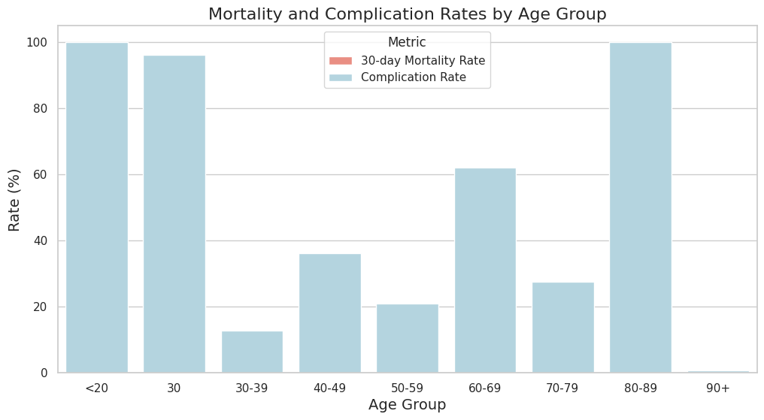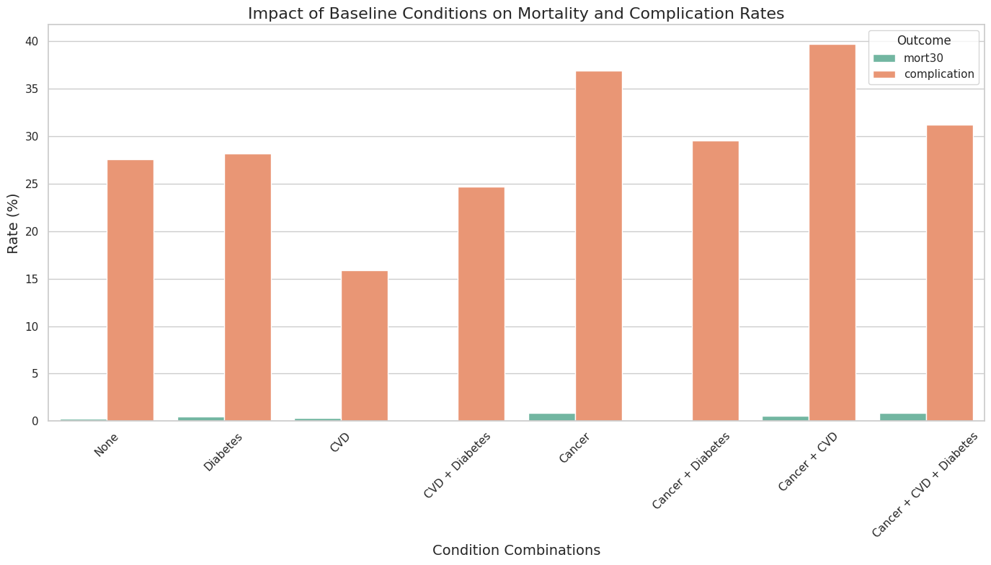
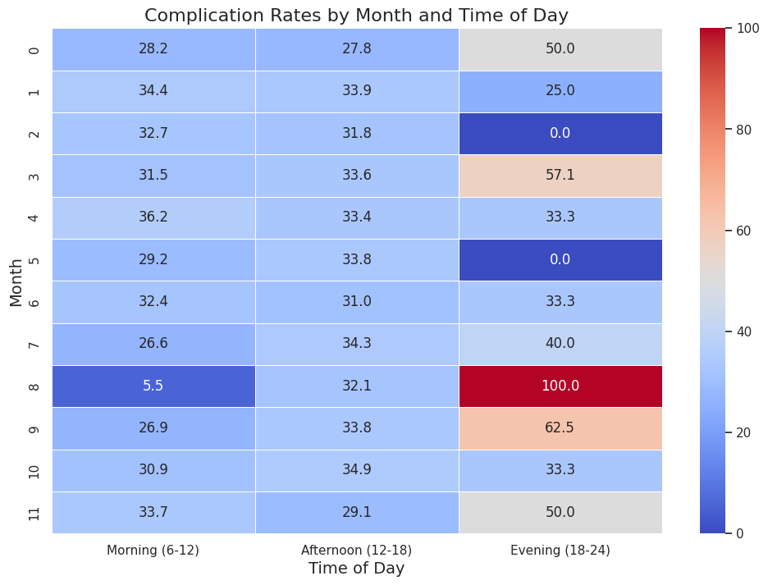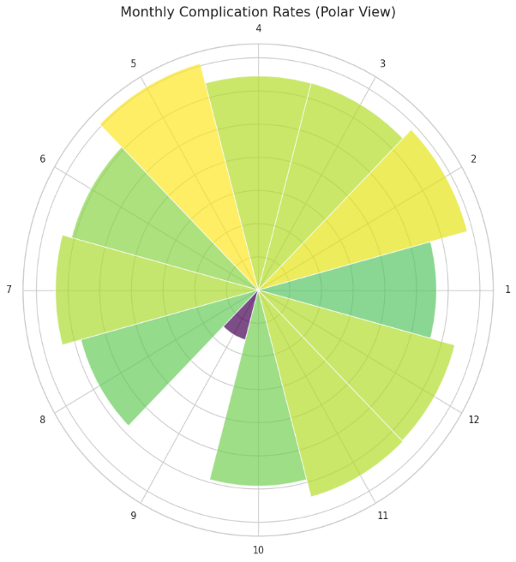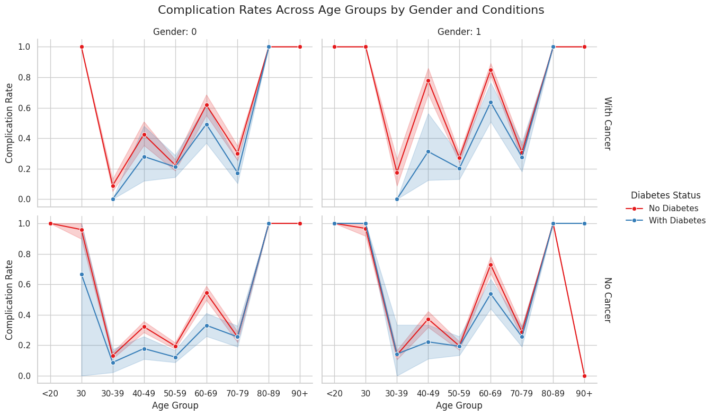

Conclusion:
In conclusion, our project on surgical data analysis aimed to develop predictive models for binary classification to forecast the likelihood of surgical complications based on patient characteristics and surgical parameters. Through thorough exploration and analysis of the dataset, we identified significant factors influencing surgical complications and mortality rates, providing valuable insights for healthcare providers to enhance patient outcomes. Utilizing a variety of machine learning algorithms, including Gradient Boosting, Random Forest, and Neural Networks, we constructed robust predictive models capable of accurately forecasting surgical complications. Additionally, feature engineering techniques, cross-validation, and error analysis were employed to optimize model performance and evaluate their effectiveness.

Furthermore, we addressed class imbalance concerns using the Synthetic Minority Over-sampling Technique (SMOTE), enhancing the representation of minority class instances and fostering more balanced model training. Our comprehensive evaluation of model performance through balanced accuracy scores, confusion matrices, and classification reports facilitated a thorough assessment of predictive capabilities and limitations.

Moreover, our project featured a series of insightful visualizations that provided a nuanced understanding of the dataset, including mortality and complication rates across different age groups, the impact of baseline health conditions, and temporal patterns of complication occurrences. These visualizations served as powerful tools for uncovering hidden insights and guiding informed decision-making processes.

Overall, our project contributes to the growing body of research in healthcare analytics by leveraging machine learning techniques and exploratory data analysis to improve surgical risk assessment and patient care. By identifying key factors influencing surgical complications and mortality rates, our findings have the potential to inform clinical decision-making, enhance risk assessment protocols, and ultimately improve patient outcomes in surgical settings.

